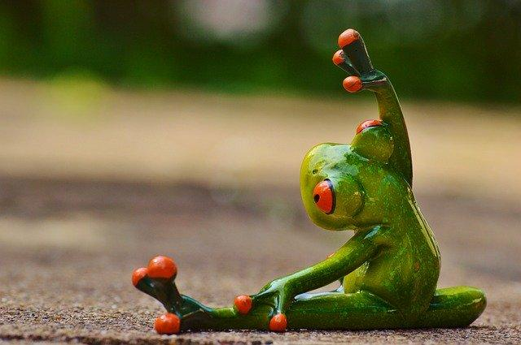
Self-care is so important for all of us. Self-care refers to activities we do to take care of our physical, emotional, and mental health. Below are some examples of some self-care activities from Kiddie Matters and Karen Horneffer-Ginter. Some of these activities require adult permission or they might be something you cannot do while we are practicing social distancing. Each one of us is different and what works for one of us won’t necessarily work for others, but that’s ok.

